**Practice Project**

**ASP.NET WEB API Application**

**Aim:**

To Create an ASP.NET WEB API Application to Add Subject Marks to Students and View Their Marks

**Github link:**

[**https://github.com/Sukirthalakshmanan1/API**](https://github.com/Sukirthalakshmanan1/API)

[**https://github.com/Sukirthalakshmanan1/WEBAPI3**](https://github.com/Sukirthalakshmanan1/WEBAPI3)

**Procedure:**

* Create an ASP.NET Web application.Select WEB API application.
* Create Business Logic Library,Data Access Library,Helper Library for student marks.
* Add dependencies for the Project.
* Add controller named Sub and Add GET,POST,PUT,Delete methods and access the operation with the help of helper class.
* Add model class marks.cs in Model Folder and write the necessary properties like student id,student name,subject marks
* Download Postman Application and create an account.
* Run the project and copy the URL and paste it in Postman.
* Test the Method GET(<https://localhost:44300/api/Sub>)
* POST Method(/api/controller) ,PUT(/api/controller/id)
* Delete(/api/controller/id) and to find the Student marks with id(<https://localhost:44300/FindById/2>)
* Add project ASP.NET application and select MVC application
* Download microsoft.ASPNET.webapi.client from nuget package manager
* Add dependencies.
* Add controller to perform List and create Operation
* Add model class mark.cs in model
* Create views Index,Create,Delete,Edit and details to perform operations.
* From solution of the project. select start up project and select project build order.
* Set the WEB API start and MVC application start
* Run the project.

**Output:**

**GET:**

List of students with their marks: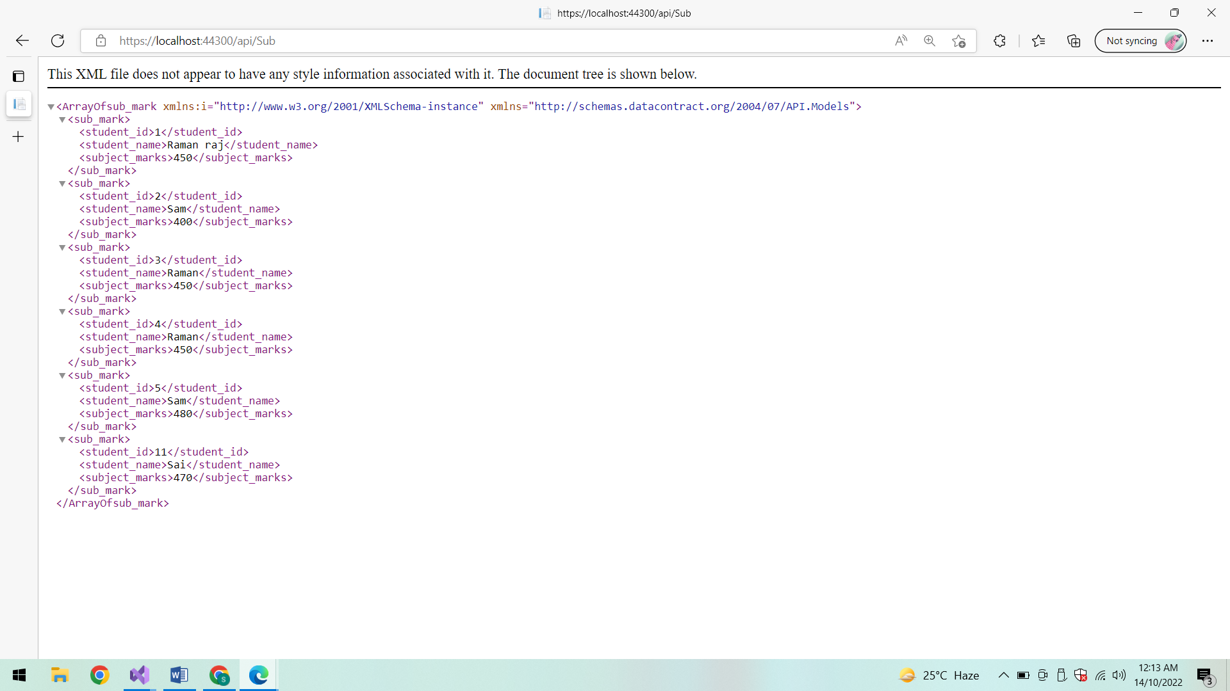

**POSTMAN:**

**GET:**

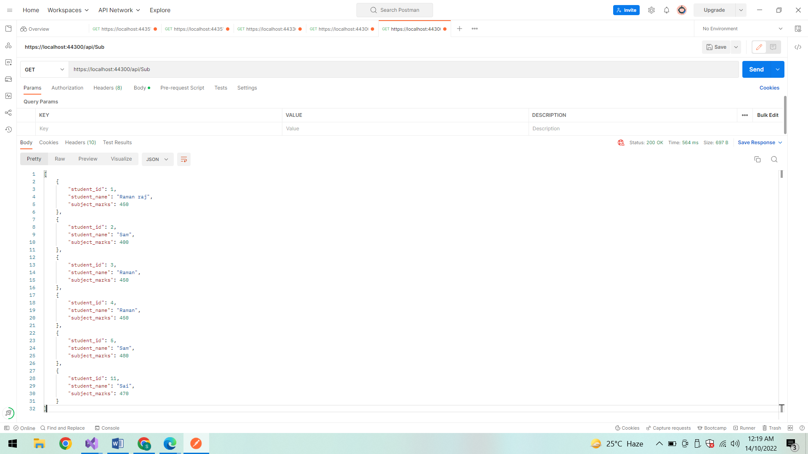

**DELETE:**

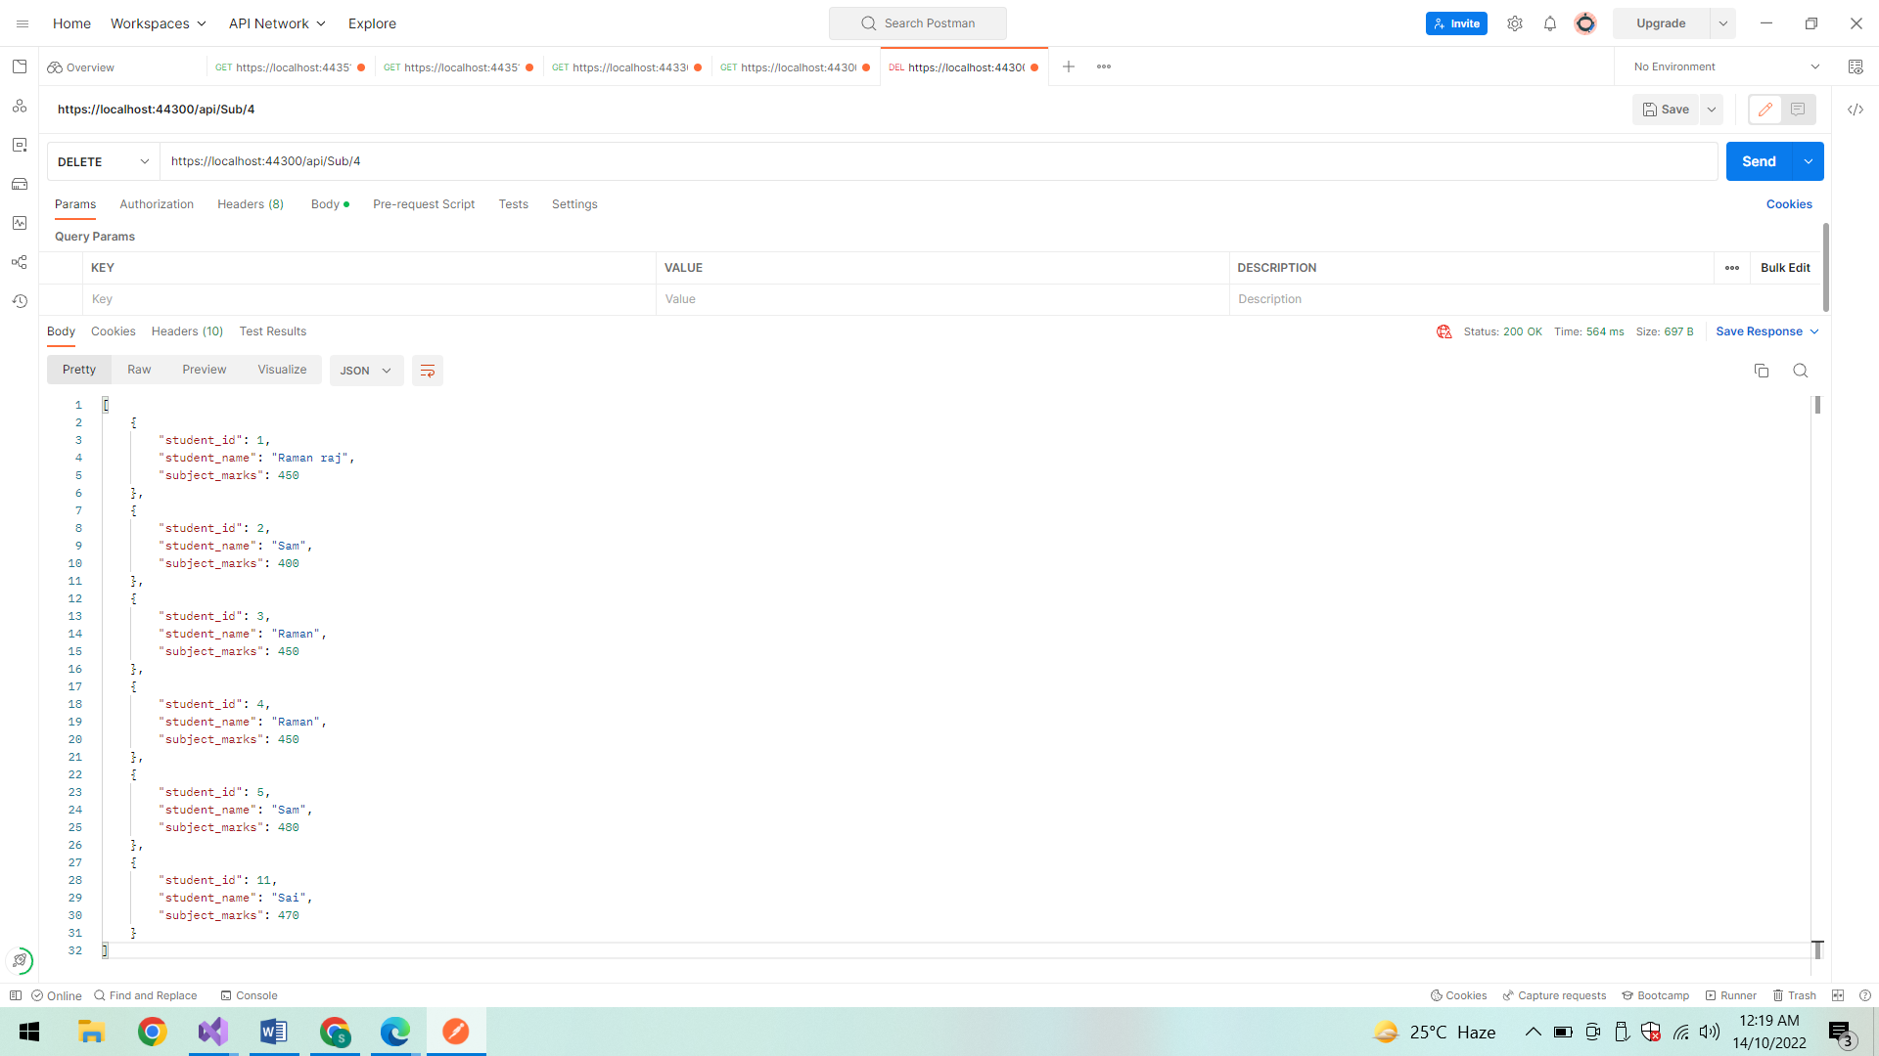

**After Deletion:**

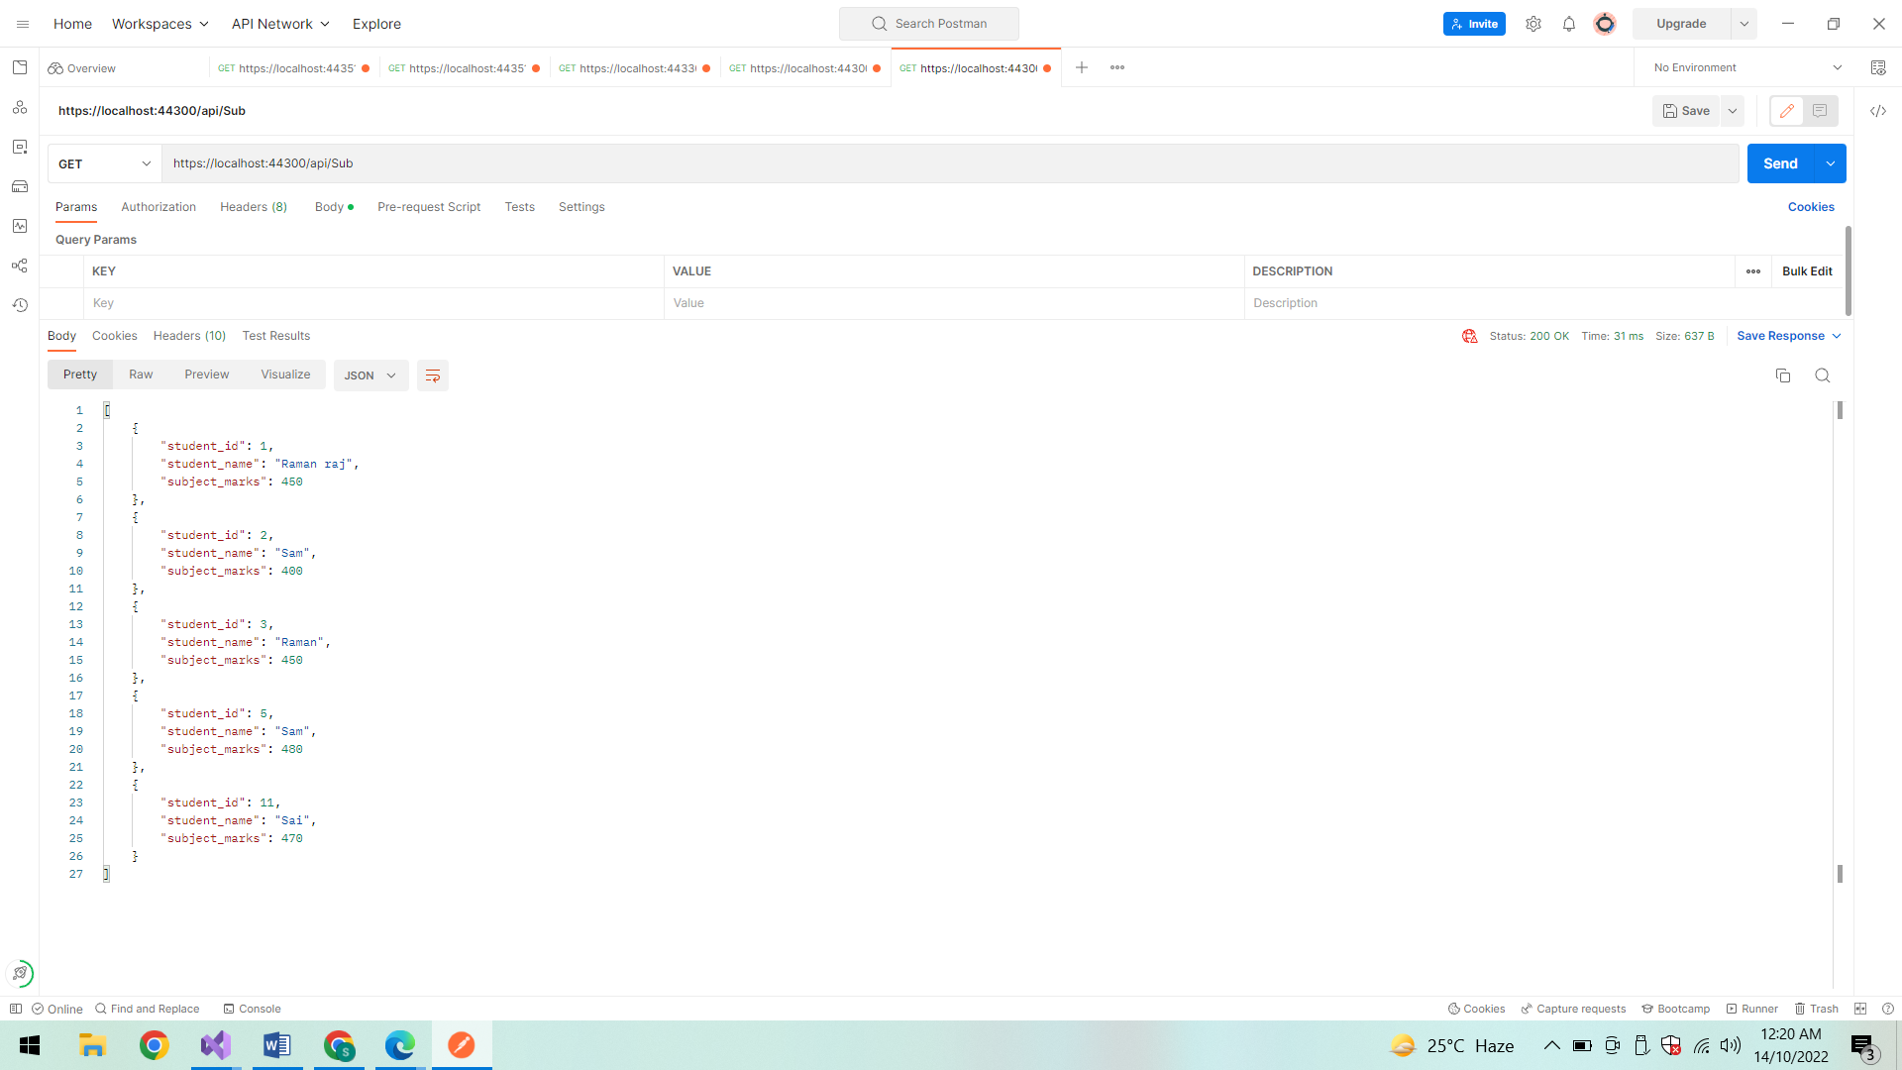

**POST:**

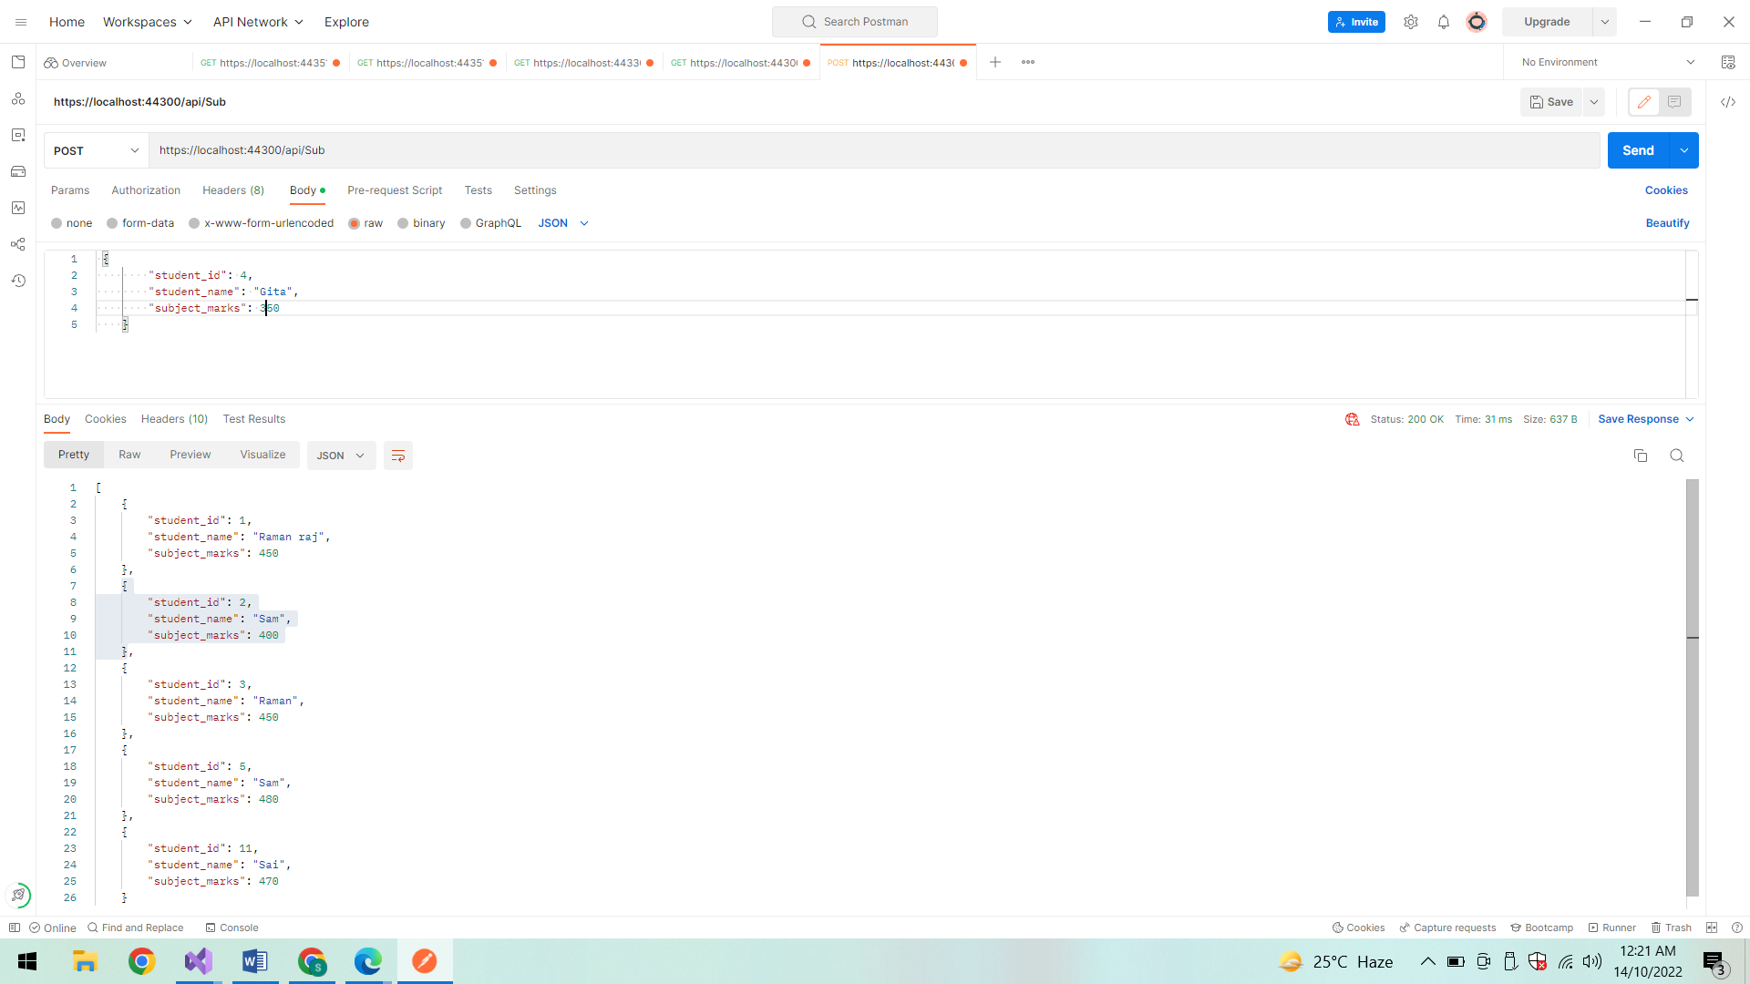

**Success status code:**

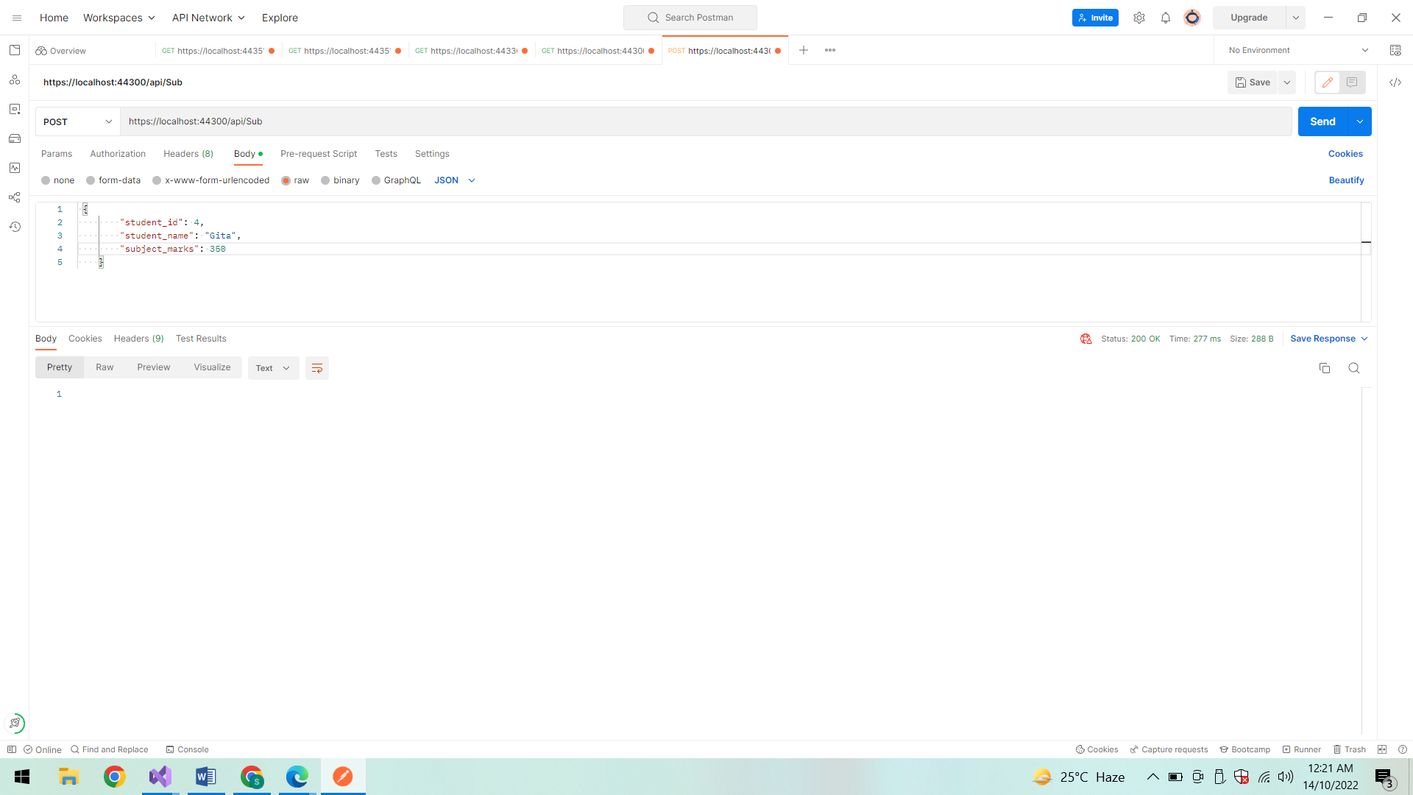

**After Insertion:**

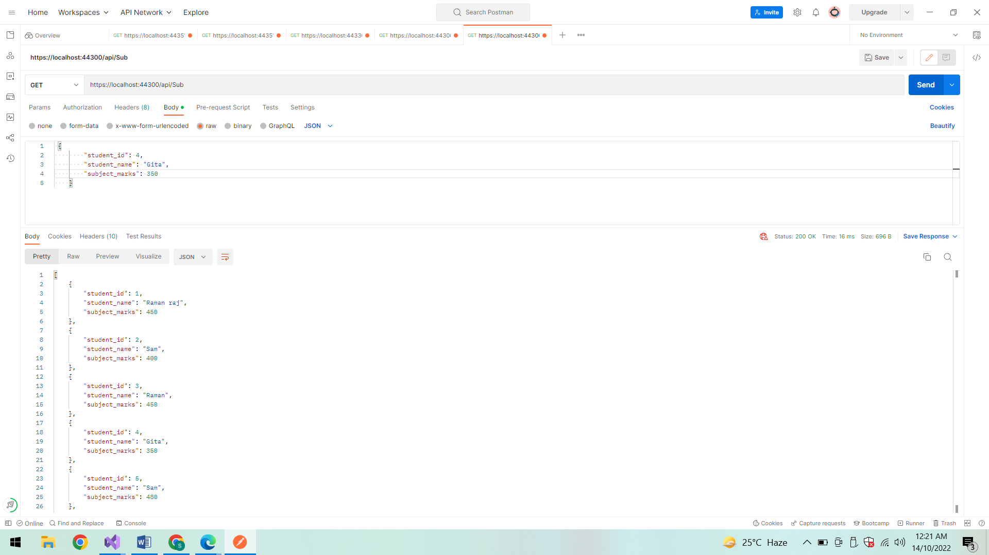

**PUT:**

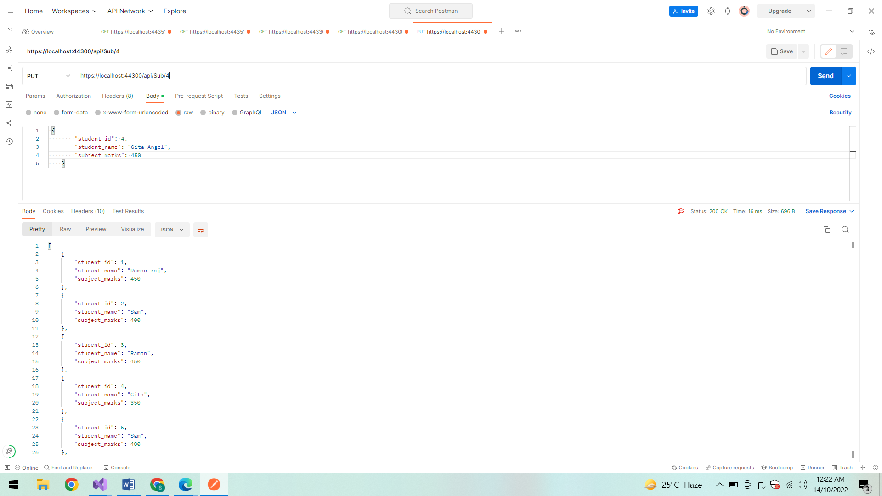

**Success Status Code:**

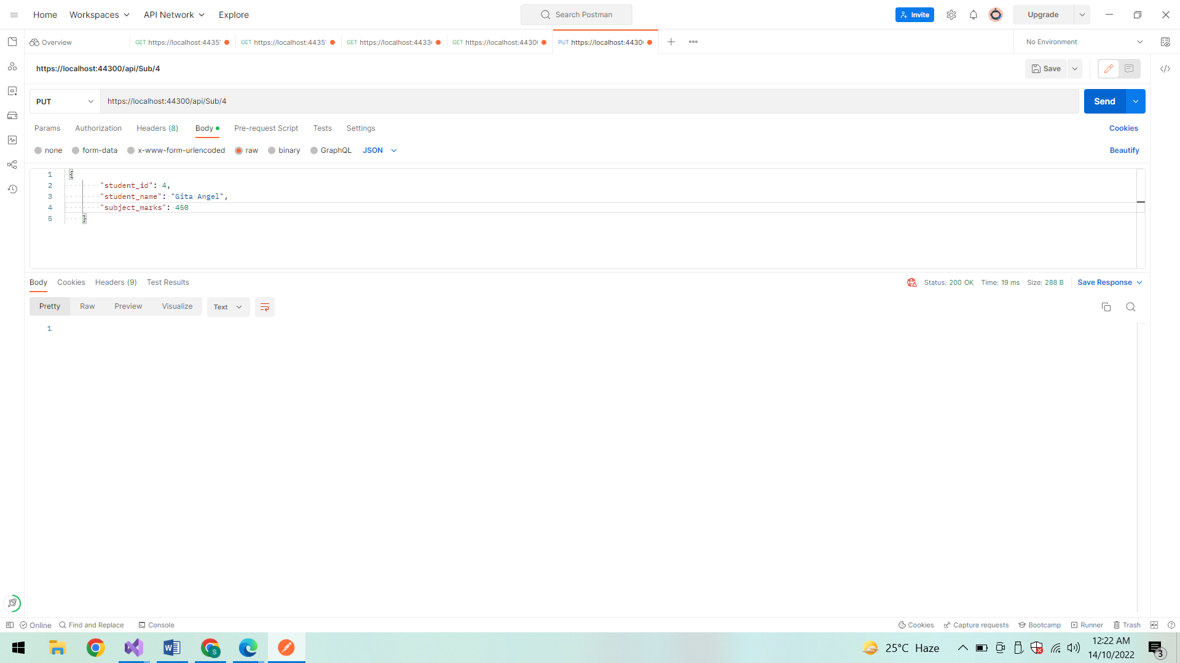

**After Updation:**

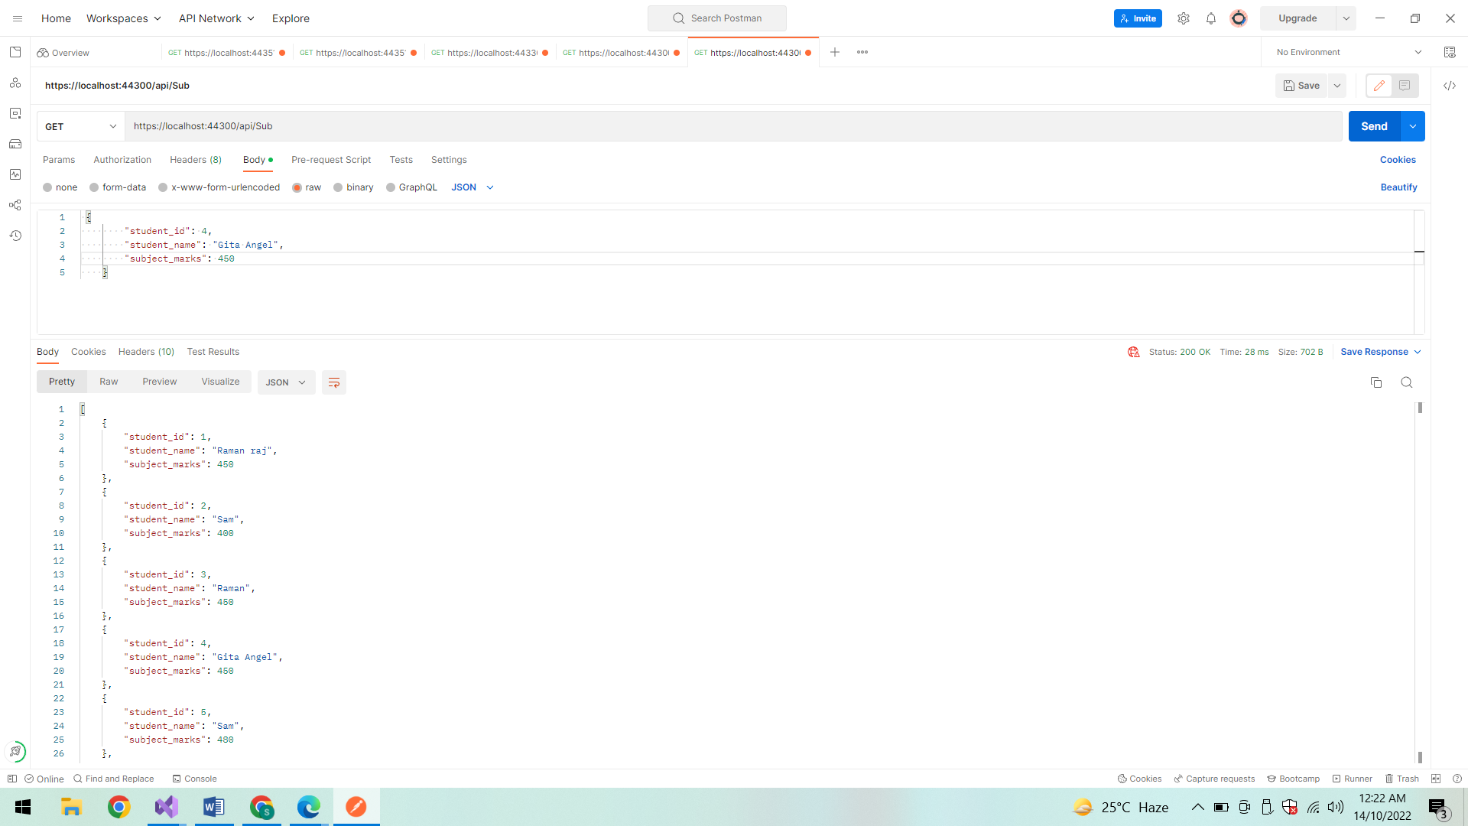

**Find By ID:**

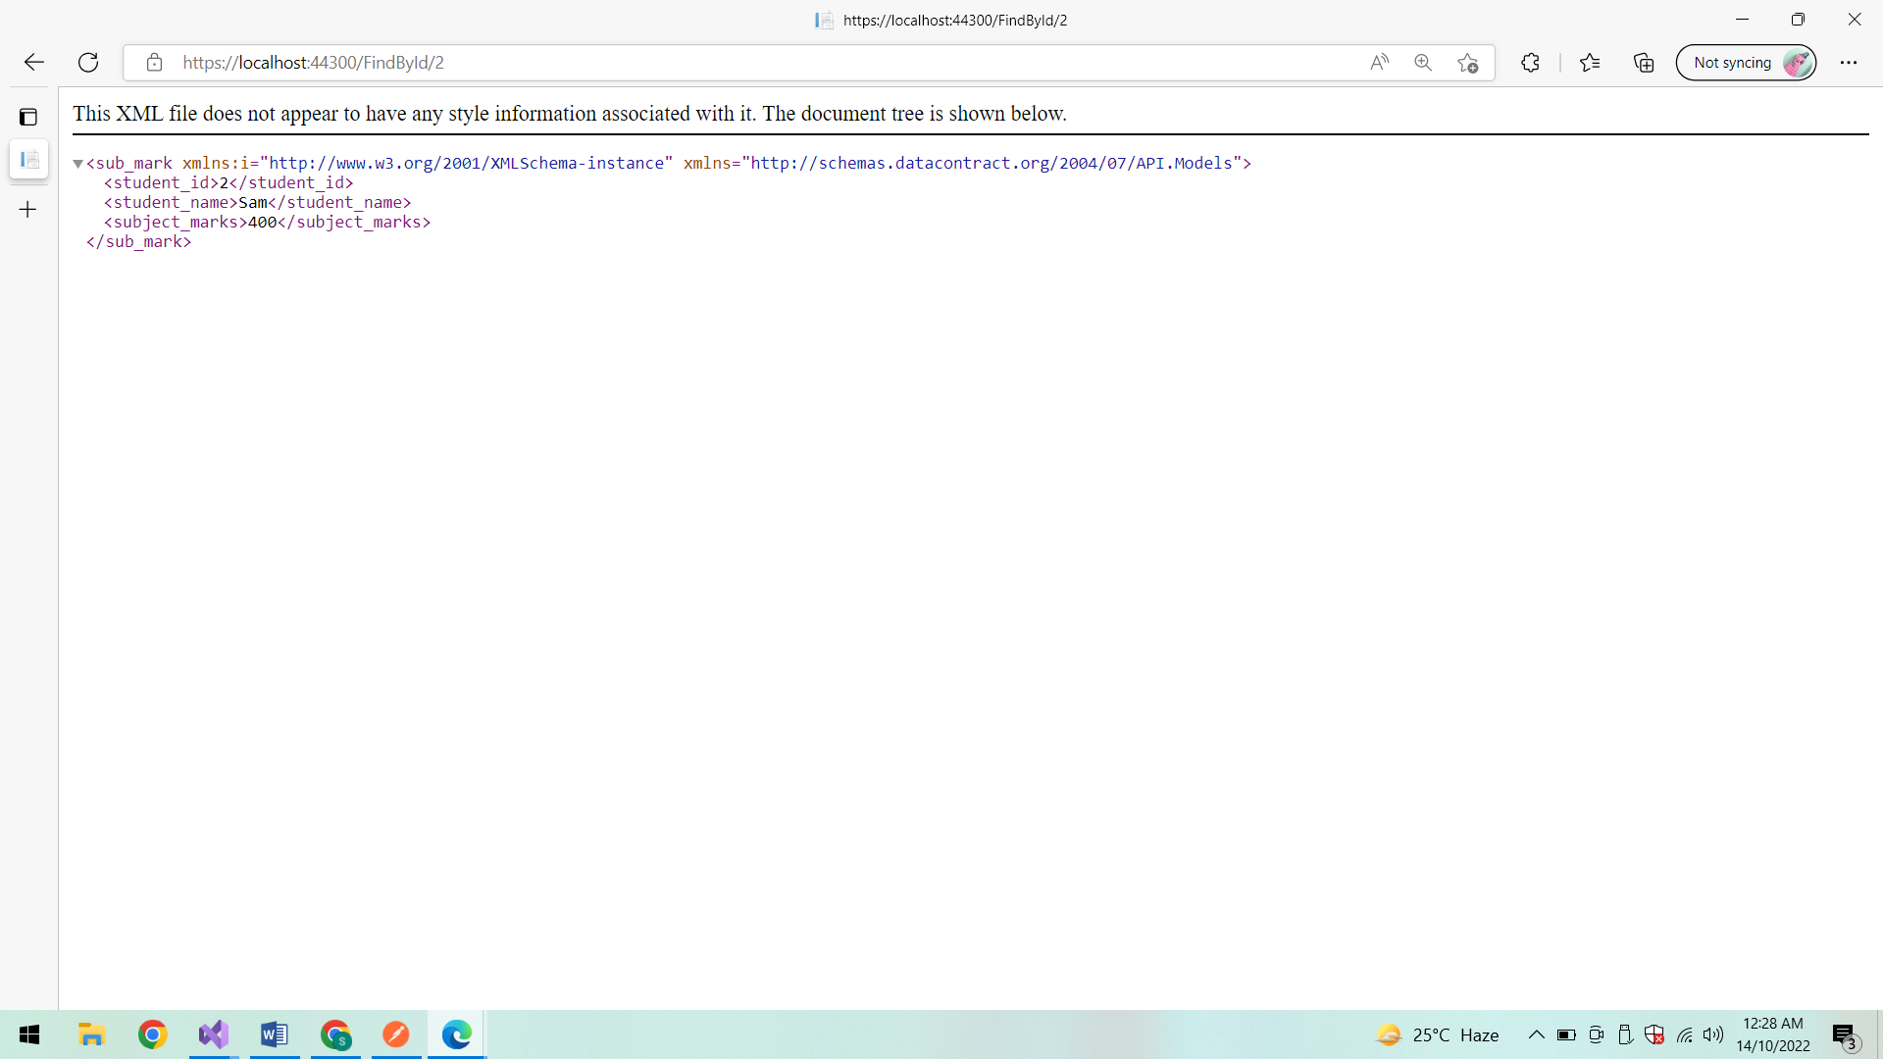

**In POSTMAN:**

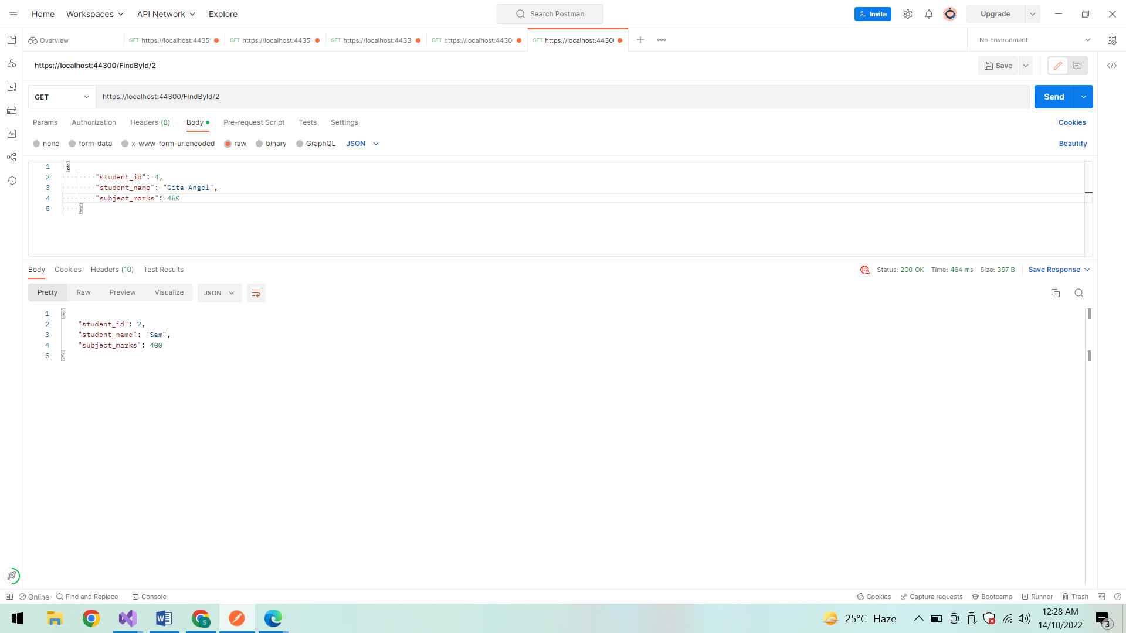

**Index:**

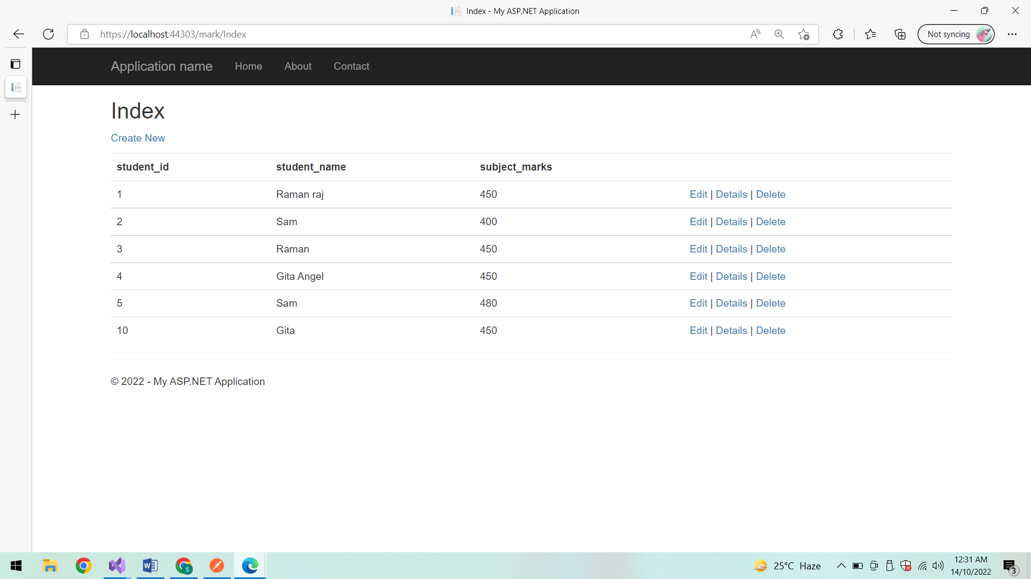

**Create:**

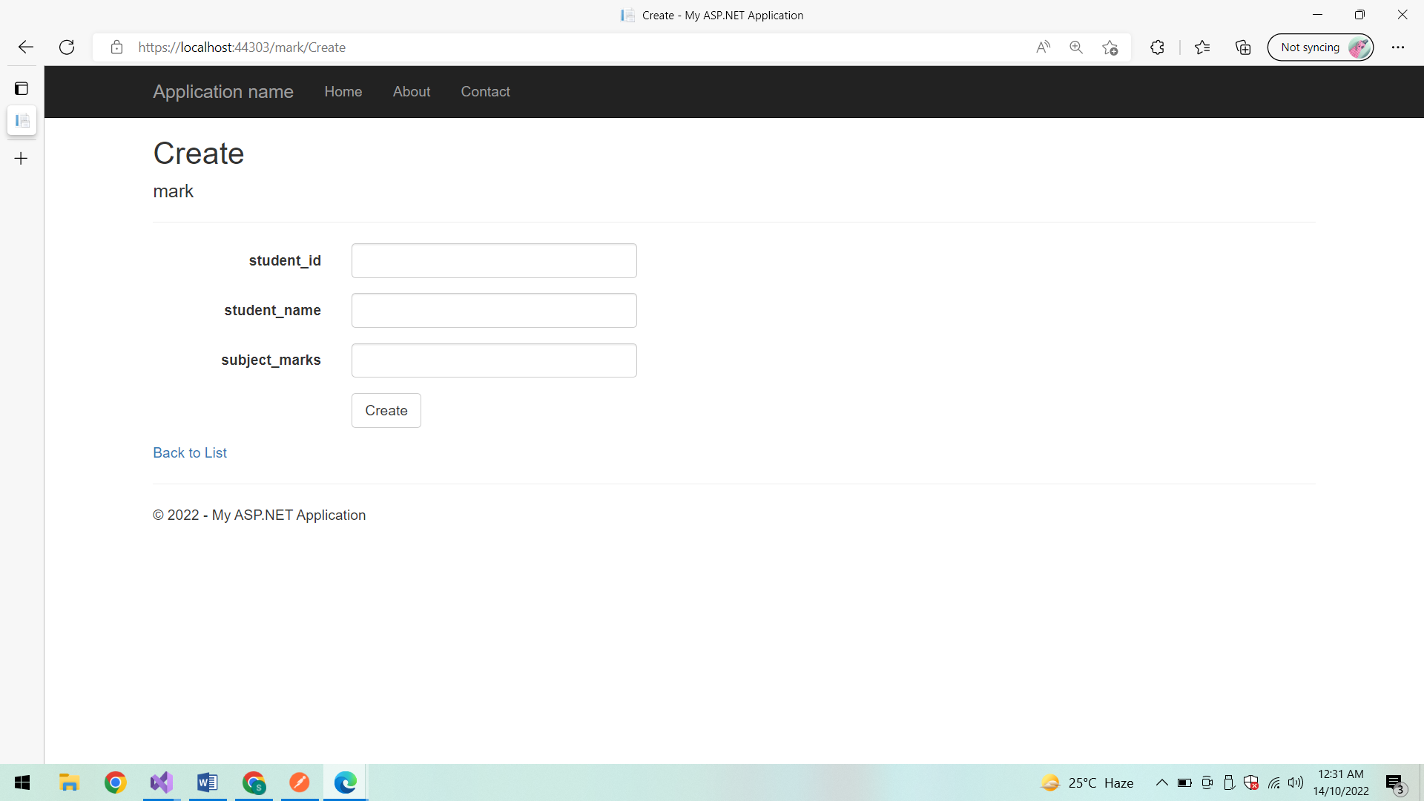

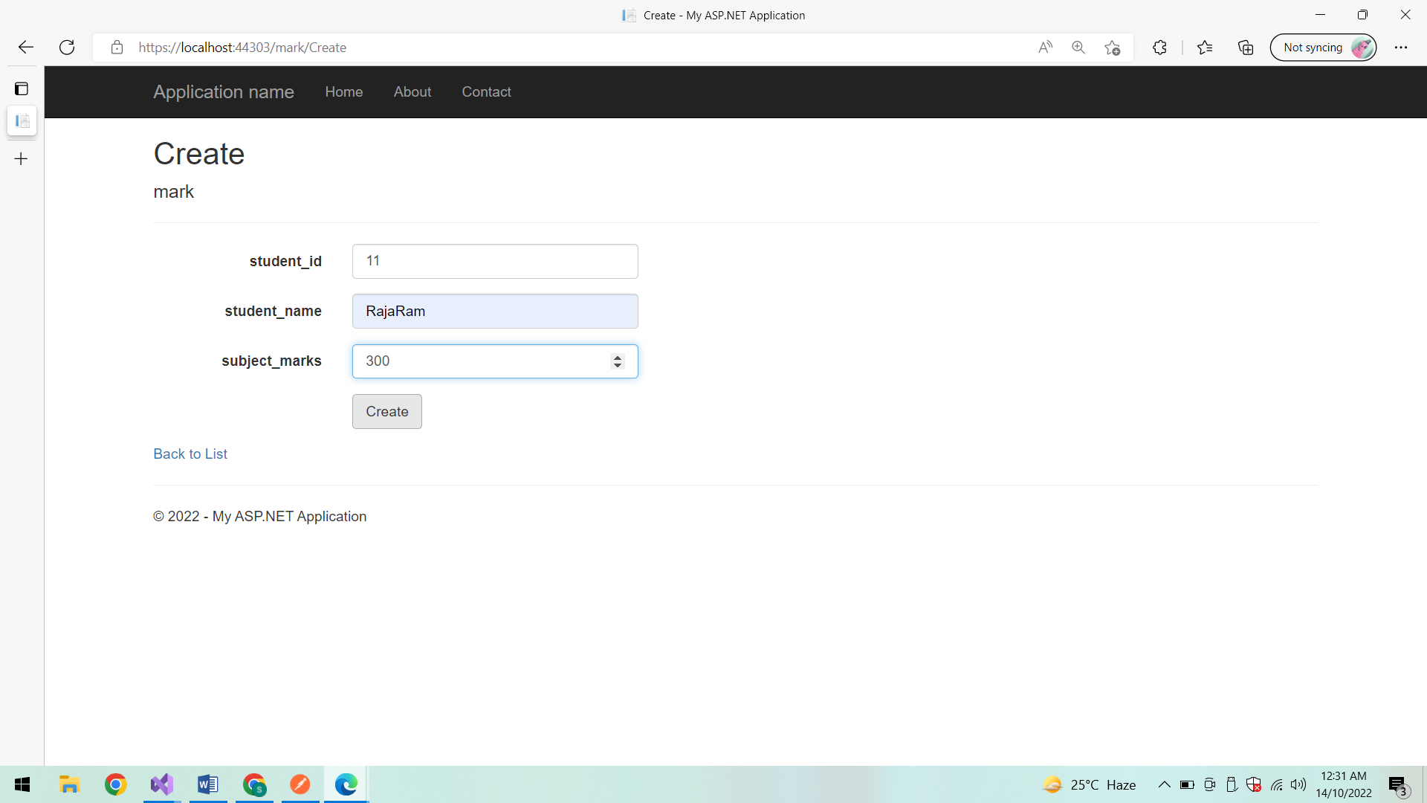

**List of student with marks:**

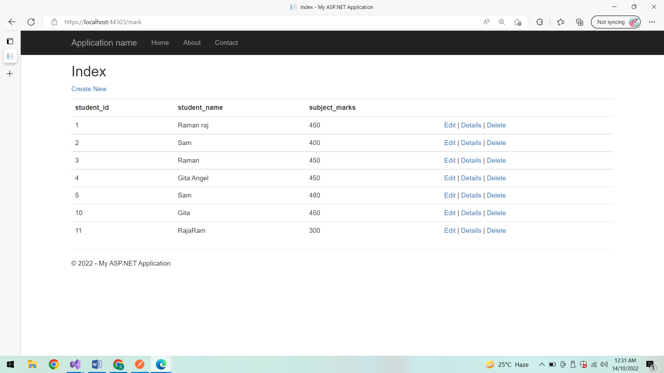

**Conclusion:**

Thus the Web API application is created successfully.